CLOUDWATCH AND CLOUDTRAIL TASKS

1) Enable cloudtrail monitoring and store the events in s3 and cloudwatch log events.
CloudTrail Setup Steps
- Go to CloudTrail console and click “Create trail”.
- Name the trail (e.g., “trail1”).
- Select a dedicated S3 bucket for storage (use a centralized bucket, like “trls3”).
- Enable log file validation for security.
- In Data Events section, use advanced event selectors to log only essential activities (e.g., only “DeleteObject”) for cost control.
- Check “Apply trail to all regions” for complete coverage.
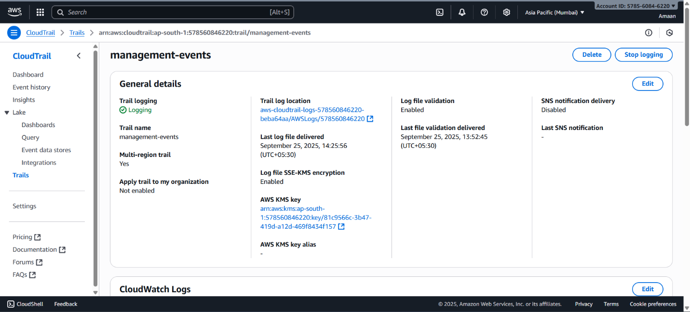
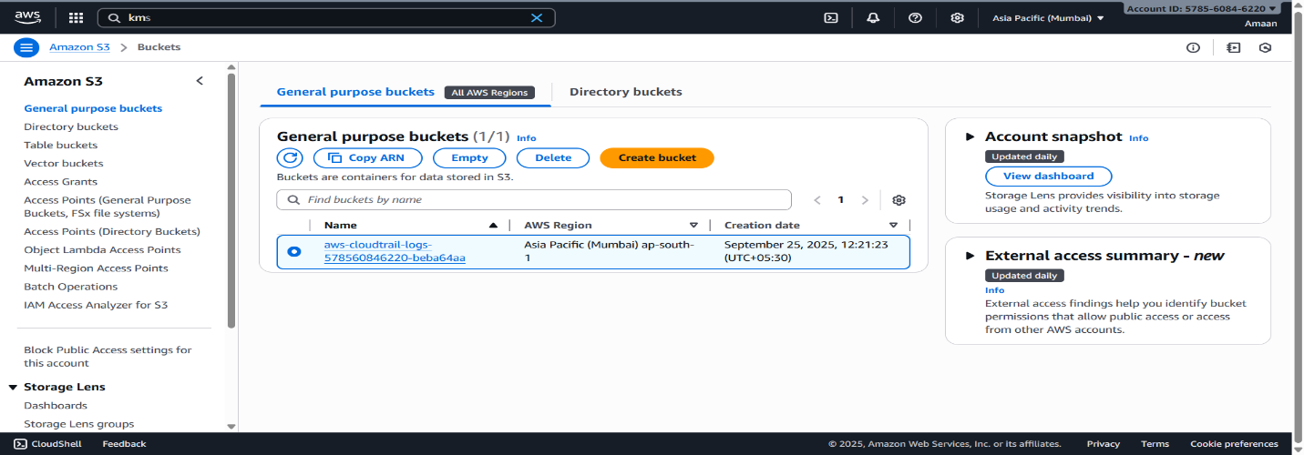

CloudWatch Logs Integration
- After trail creation, enable CloudWatch Logs delivery (“cwlog1” as group name).
- Assign or create an IAM role (e.g., “trlrole”) that permits CloudTrail to publish events to CloudWatch Logs.
- In CloudWatch, configure metric filters and alarms for suspicious activities, like IAM policy changes, using relevant patterns.
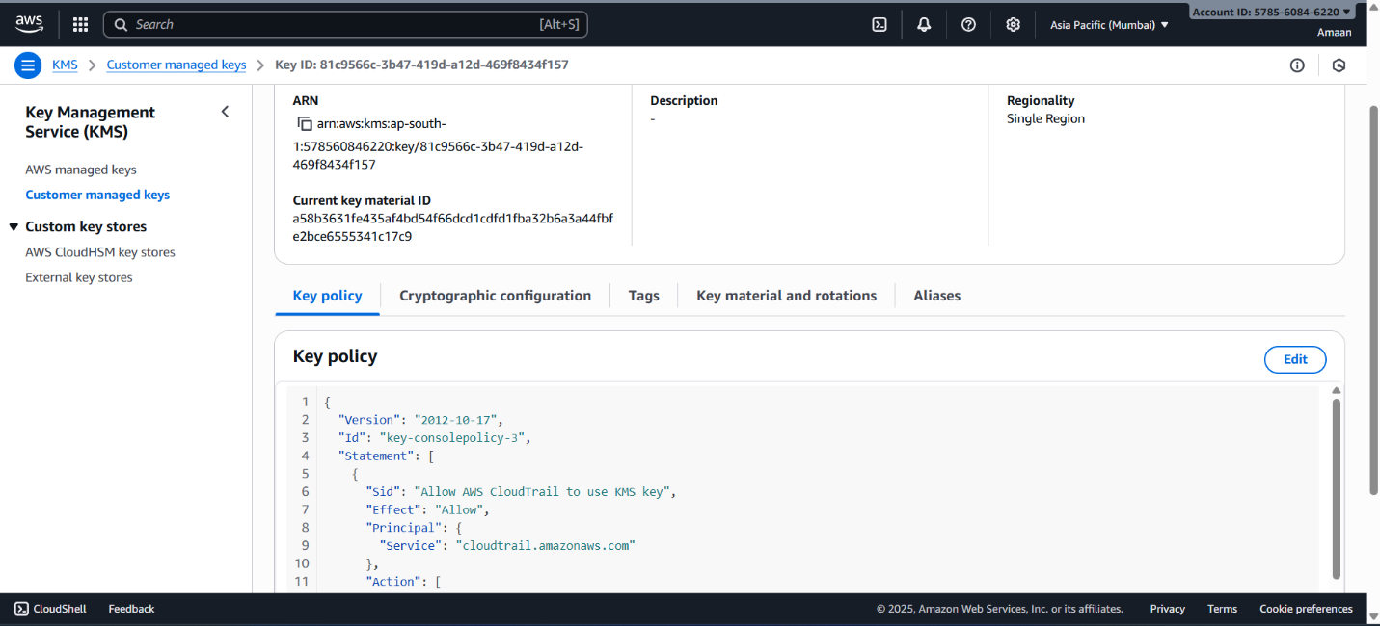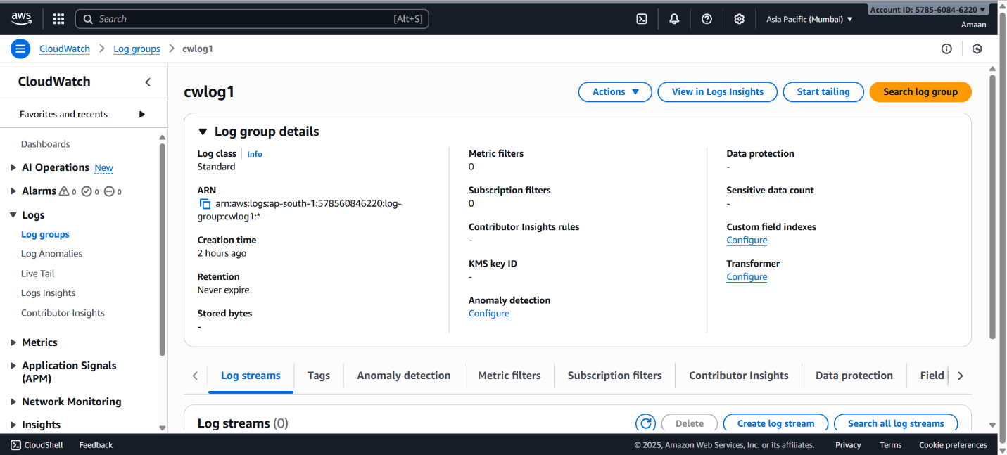

2) Enable SNS for cloudtrial to send alert on email.
Steps to Enable SNS Alerts for CloudTrail
- Create SNS Topic
  - Go to the SNS console.
  - Create a topic (e.g., "CloudTrailAlerts").
  - Note the ARN of the SNS topic.
- Subscribe Email Endpoint
  - Create a subscription on the SNS topic for your email address.
  - Confirm the subscription by clicking the confirmation link in the email sent.
- Configure CloudTrail to Use SNS
  - In the CloudTrail console, edit or create a trail.
  - In “SNS notification delivery” section, enable SNS.
  - Select the SNS topic created ("CloudTrailAlerts").
  - CloudTrail will now send notifications about log delivery and failures to the subscribed email.
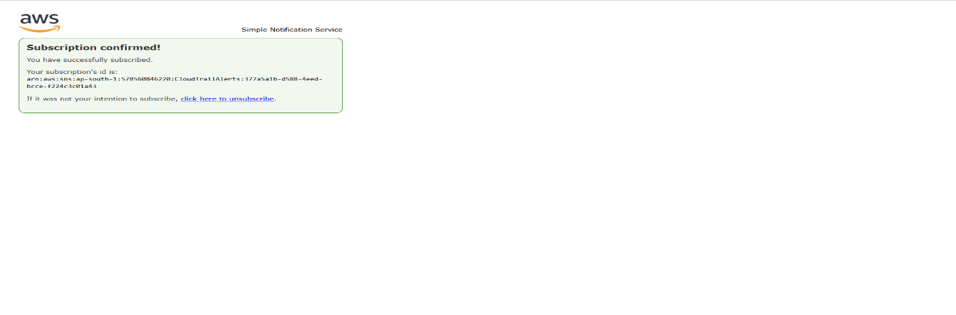
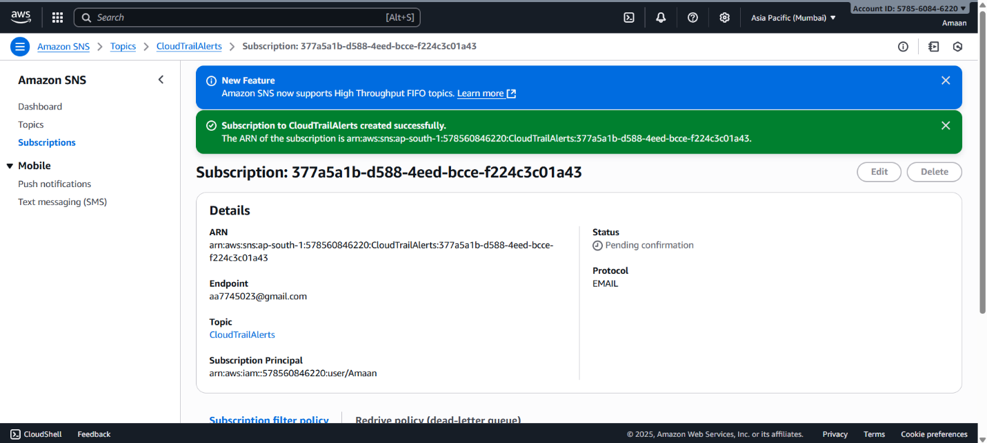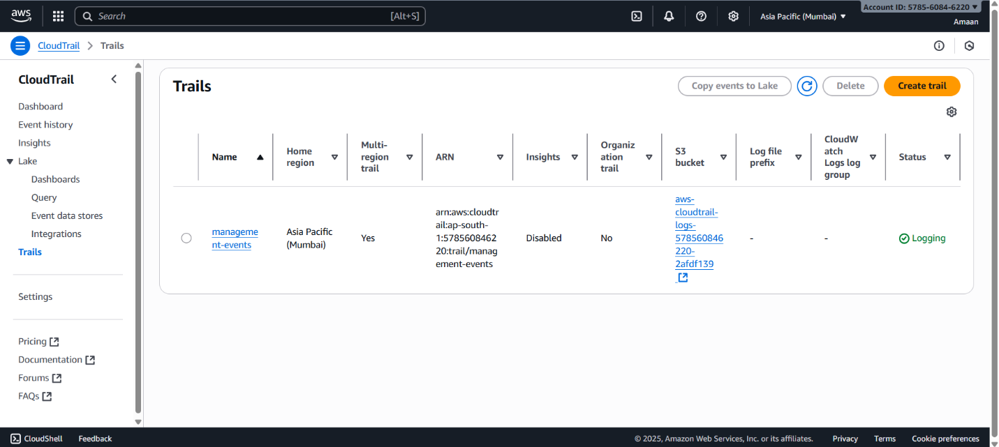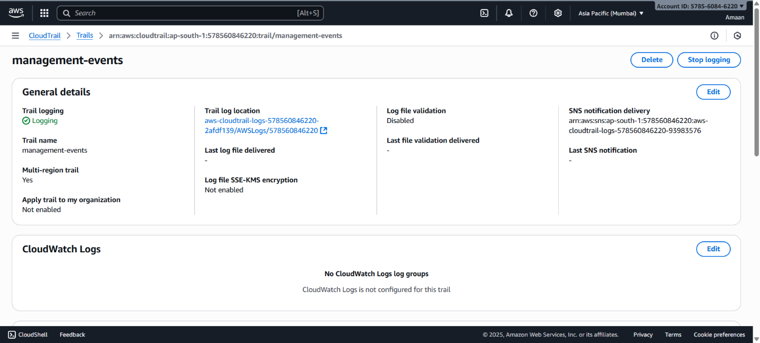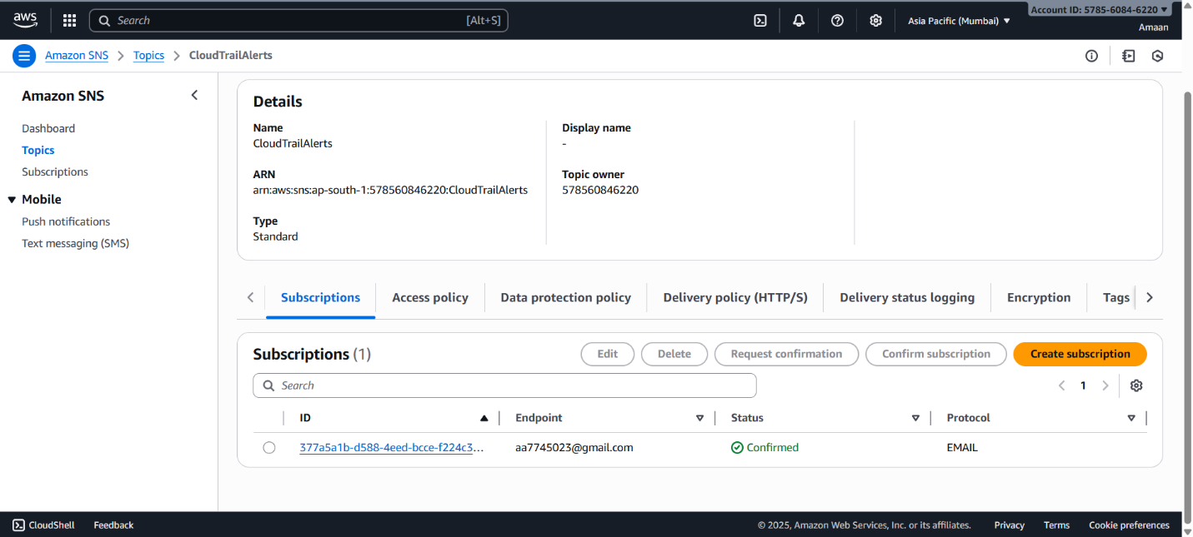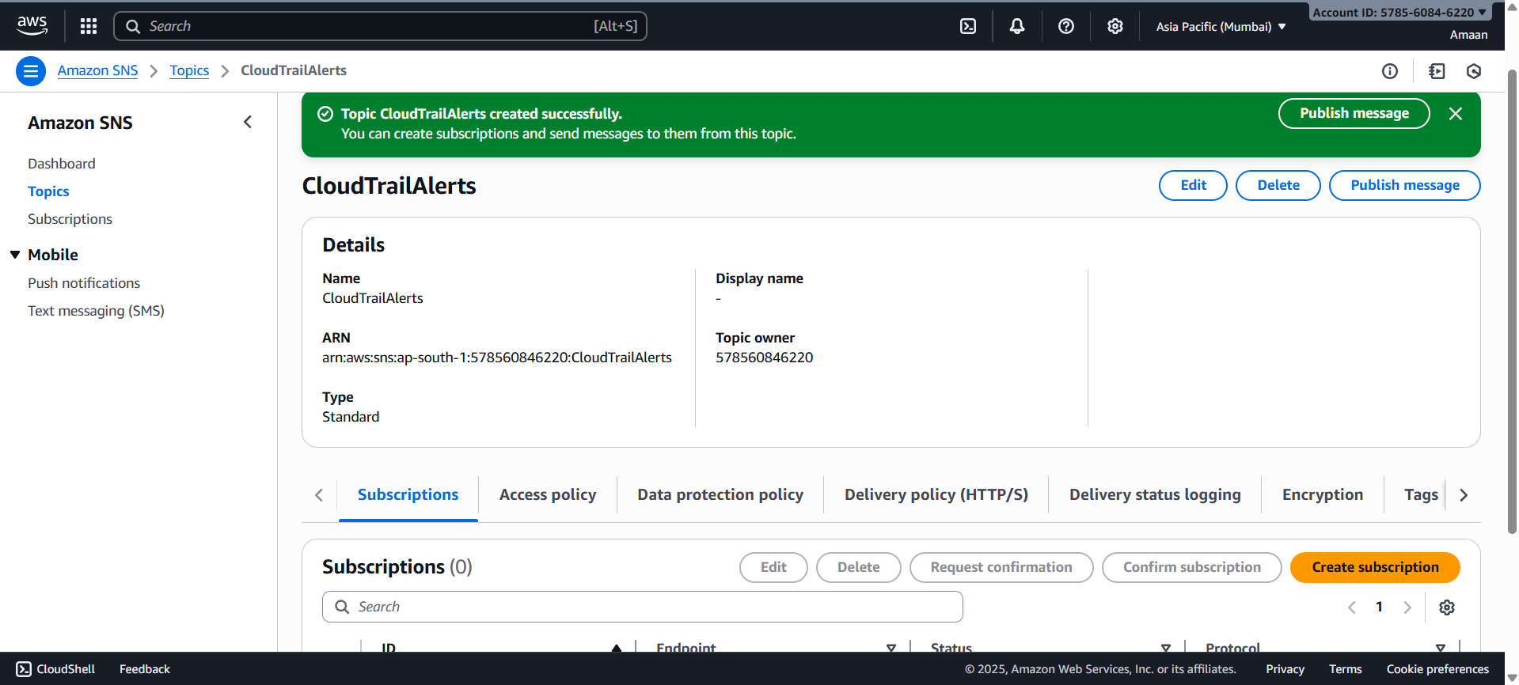

3) Configure cloud watch monitoring and record the cpu utilization and other metrics of ec2.
Steps to Create CloudWatch Dashboard or Alarms for EC2 Metrics
- Go to CloudWatch console → Metrics → EC2
- Select metrics like CPUUtilization, DiskReadOps, NetworkIn for desired instances.
- You can create Alarms on these metrics:
  - Click “Create Alarm”
  - Specify thresholds, e.g., CPU Utilization > 80%
  - Set actions like sending SNS notifications.
- Create Dashboard (optional)
  - In CloudWatch console, choose Dashboards → Create dashboard.
  - Add widgets to display EC2 CPUUtilization and other metrics in graphs or numbers.

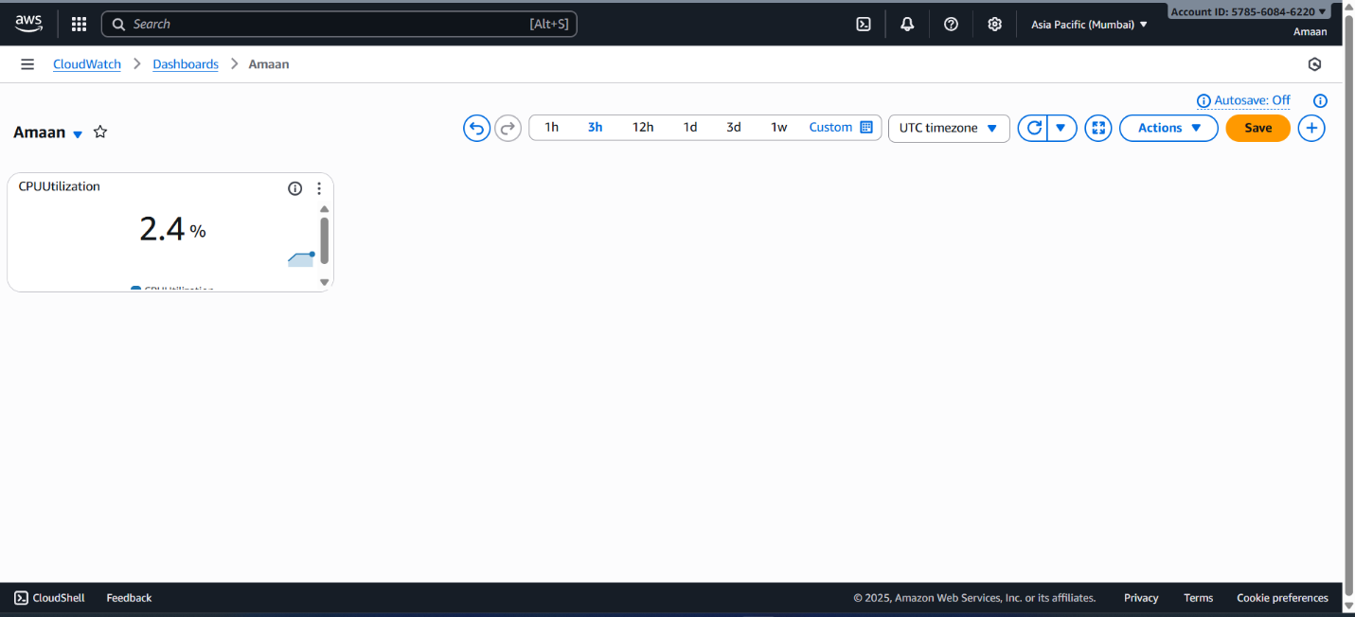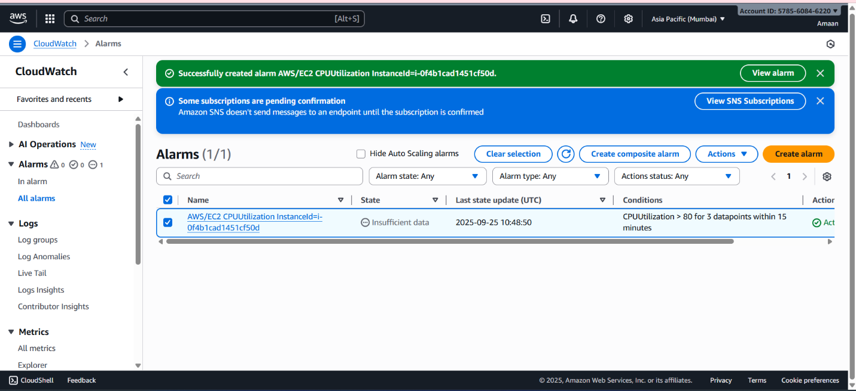

4) Create one alarm to send alert to email if the cpu utilization is more than 70 percent.

Steps to Create CPU Utilization Alarm with Email Notification
- Go to AWS CloudWatch Console → Alarms → All alarms → Create alarm.
- Select "EC2" metrics, then "Per-Instance Metrics" → Choose your instance → Select "CPUUtilization".
- Set the condition:
  - Threshold type: Static
  - Whenever CPUUtilization is Greater than 70%
  - For at least 1 out of 1 consecutive periods
  - Period: 5 minutes (or choose 1 minute if detailed monitoring enabled)
- In "Actions" section:
  - Select "In alarm" state.
  - Choose to "Add notification" → Select/create an SNS topic for sending email alerts.
  - Subscribe your email address to this SNS topic if not done already.
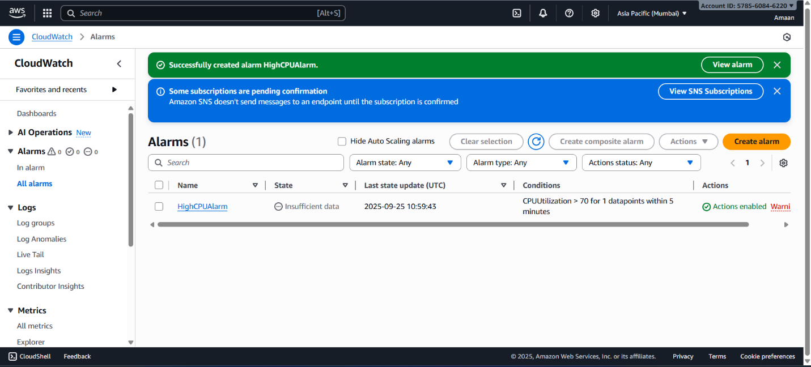

5) Create Dashboard and monitor tomcat service wether it is running or not and send the alert.

To create a CloudWatch dashboard to monitor whether the Tomcat service is running and send an alert if it is not, follow these steps:
Step 1: Install and Configure CloudWatch Agent on EC2
- Install the CloudWatch Agent on your EC2 instance running Tomcat.
- Configure the agent to collect custom metrics by executing a script that checks the Tomcat service status (e.g., using systemctl status tomcat or ps command).
- The script should publish a custom metric (e.g., TomcatStatus) with value 1 if running, 0 if stopped, to CloudWatch.
Step 2: Create a CloudWatch Dashboard
- Go to CloudWatch console → Dashboards → Create dashboard.
- Add a widget:
  - Choose "Line" or "Number".
  - Select the custom metric namespace and TomcatStatus metric created for your EC2 instance.
- This widget will show whether Tomcat is running (1) or not (0).
Step 3: Create CloudWatch Alarm for Tomcat Service
- Create an alarm on the TomcatStatus metric.
- Set condition:
  - Alarm when TomcatStatus = 0 for 1 consecutive period.
- Set alarm action to send notification to an SNS topic subscribed by your email to get alerts if Tomcat stops.
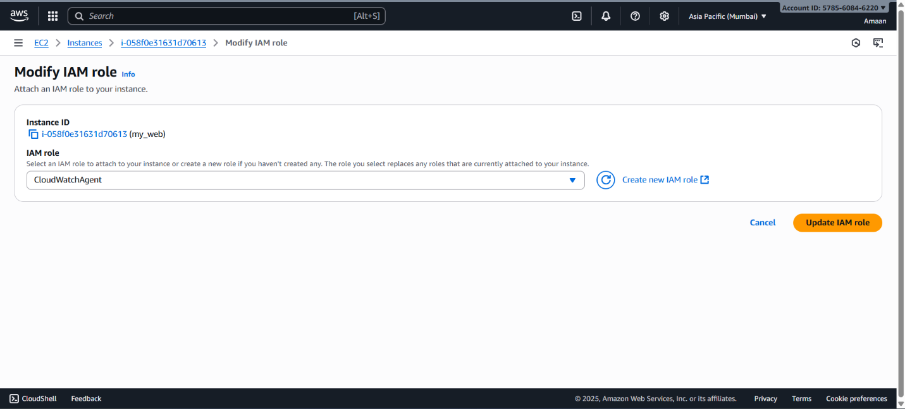
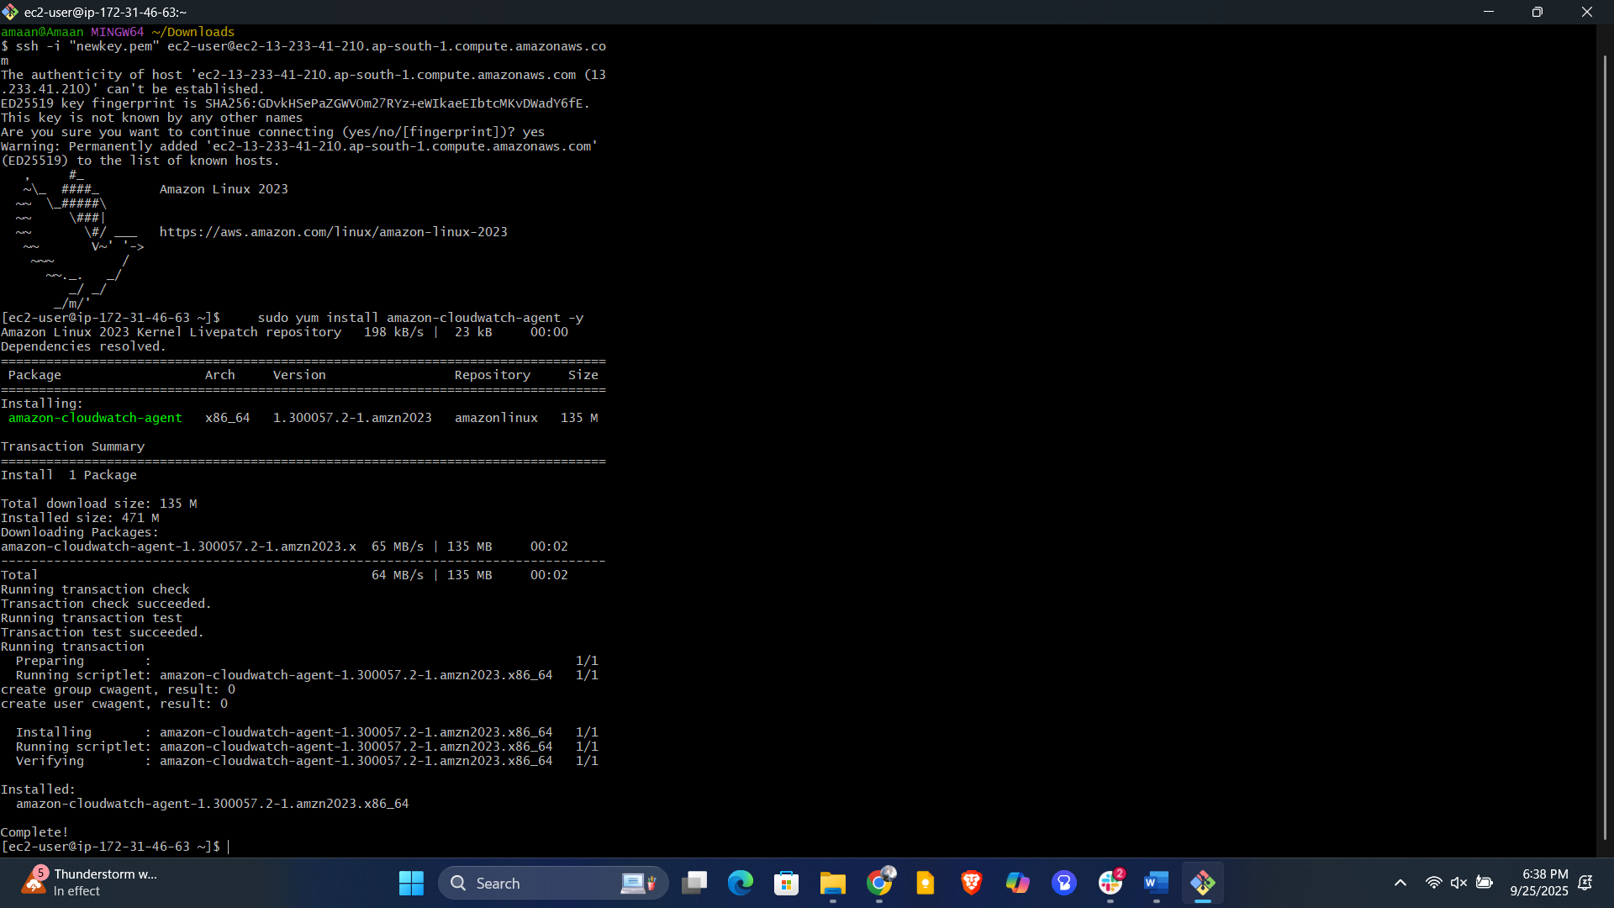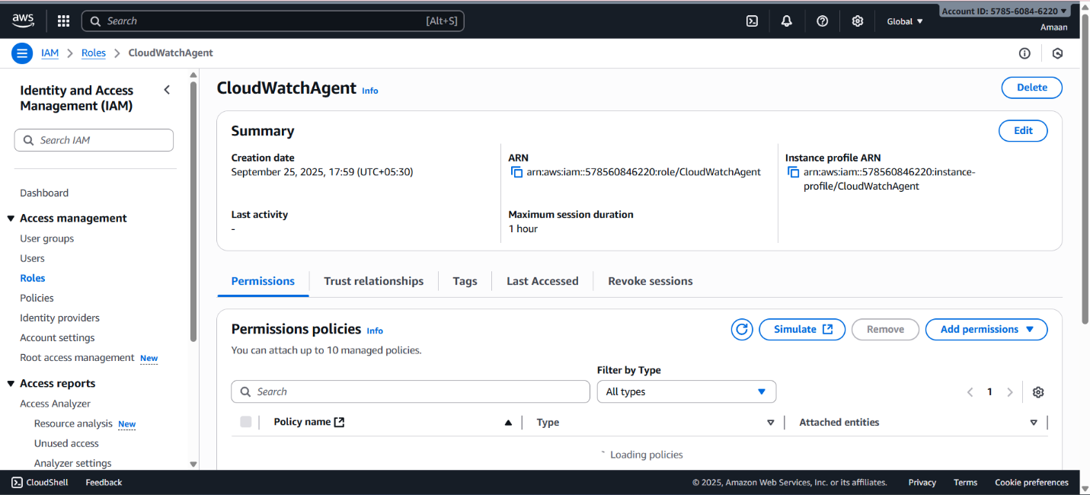

6) Create Dashboard and monitor nginx service to send the alert if nginx is not running.

To create a CloudWatch dashboard to monitor the Nginx service and send alerts if Nginx is not running, follow this approach:
Step 1: Install CloudWatch Agent and a Script for Nginx Status
- Install CloudWatch Agent on your EC2 instance running Nginx.
- Create a script to check Nginx service status, for example:
bash
#!/bin/bash
if systemctl is-active --quiet nginx; then
status=1
else
status=0
fi
# Publish metric to CloudWatch
aws cloudwatch put-metric-data --metric-name NginxStatus --namespace "Custom/Nginx" --value $status --region YOUR_REGION
- Schedule this script to run every minute using cron.
Step 2: Create CloudWatch Custom Metric Dashboard
- In CloudWatch console, create a Dashboard.
- Add widget to show metric NginxStatus under namespace Custom/Nginx.
- This widget displays 1 when Nginx is running, 0 if stopped.
Step 3: Create CloudWatch Alarm on Nginx Service
- Create an alarm on NginxStatus metric.
- Set alarm condition to trigger when metric = 0 for 1 consecutive period.
- Configure the alarm to send notifications to an SNS topic that emails you alerts.

